# [Mariska Hargitay and Christopher Meloni's Onscreen Chemistry Led to a Sweet Offscreen Friendship](https://www.popsugar.com/celebrity/mariska-hargitay-christopher-meloni-friendship-47708507/amp?utm_medium=twitter&utm_source=post&utm_campaign=frontdoor&__twitter_impression=true&s=09)



Aug 24 2020*by* [GRAYSON GILCREASE](https://www.popsugar.com/author/Grayson-Gilcrease)

949

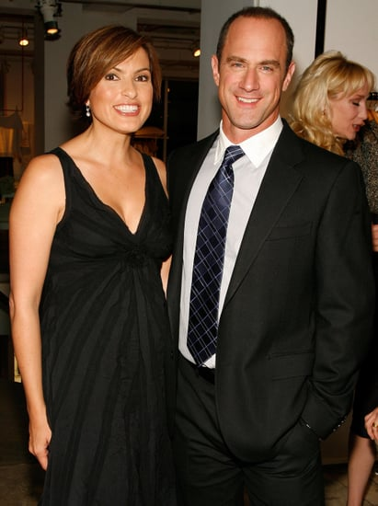

Mariska Hargitay and Christopher Meloni make up one of TV's most beloved duos: [**Law & Order: SVU**](https://www.popsugar.com/Law-&-Order)'s Olivia Benson and Elliot Stabler. While their onscreen chemistry has had many fans hoping [their characters would get together](https://www.popsugar.com/entertainment/Who-Has-Olivia-Benson-Dated-Law-Order-43880557), their offscreen relationship has actually been one [adorable decades-long friendship](https://www.popsugar.com/celebrity/mariska-hargitay-christopher-meloni-best-pictures-46627787). From [their lunchtime selfies](https://www.popsugar.com/celebrity/mariska-hargitay-christopher-meloni-instagram-july-2020-47628683) to social media exchanges, their reunions have always given people hope that Chris would one day return to **SVU**. Thankfully, [their wish has been granted](https://www.popsugar.com/entertainment/law-and-order-svu-spinoff-with-christopher-meloni-details-47357546) with Chris's **SVU** spinoff. Hopefully this means we [get to see even more glimpses](https://www.popsugar.com/entertainment/christopher-meloni-mariska-hargitay-on-law-order-spinoff-47656060) of Mariska and Chris's relationship. Until then, you can read quotes about their friendship ahead.

Image Source: [Getty / Joe Kohen](http://www.gettyimages.com/)

## **Mariska Hargitay's Quotes on Christopher Meloni**



* "From the second we met, [bells went off](https://www.tvinsider.com/714620/mariska-hargitay-law-order-svu-season-20-ending-benson-stabler/). We knew we were going to be a huge force in each other's lives. He was intense and mercurial but also fun."
* "[H]e and I, from minute one were [doing] all this shtick, and laughing. It was nonstop chitchat; couldn't stop talking. All of a sudden someone comes out and pairs us up: 'Mariska and Chris.' And I thought. 'I [want to be with that guy](https://www.today.com/popculture/mariska-hargitay-chris-meloni-have-sweetest-law-order-svu-memories-t171075)!' Because we already had a thing."
* She describes her relationship with Chris as one with "[instantaneous ease, trust, comfort](https://people.com/tv/mariska-hargitay-christopher-meloni-svu-chemistry/)."

Image Source: [Getty / Jim Spellman](http://www.gettyimages.com/)

## **Christopher Meloni's Quotes on Mariska Hargitay**

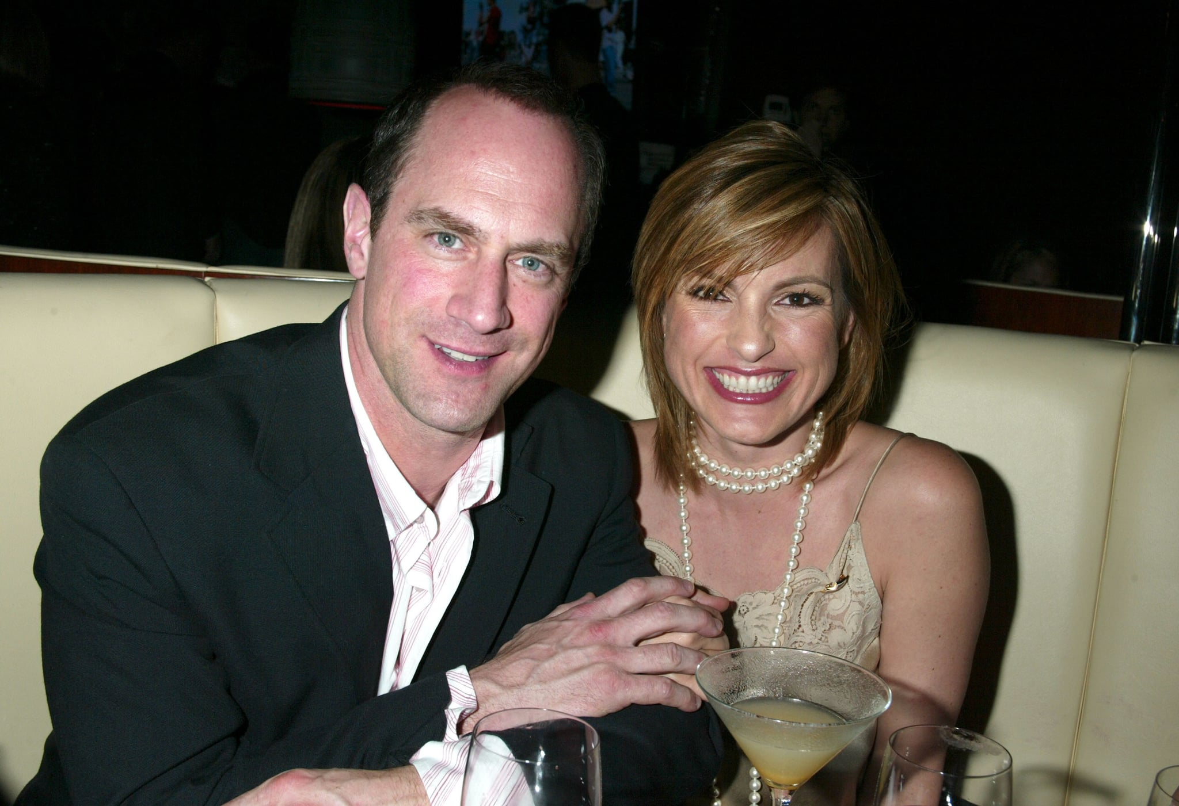

* "I just knew that Mariska was going to be 'The One.' I was in the middle of telling her this story, this joke. So we got up on the stage and I'm like, 'Hold on just a second, I'm going to finish telling this story.' Not being disrespectful, but this is important too. This may change my life, but the story is that funny. And I think that put us at ease, and unconsciously there was a connection you could see: That [she was now my partner](https://www.today.com/popculture/mariska-hargitay-chris-meloni-have-sweetest-law-order-svu-memories-t171075)."
* "She and I hit it off right from the get-go . . . it's always been [a huge part of our relationship](https://www.cinemablend.com/television/2487684/law-and-order-svus-mariska-hargitay-and-christopher-meloni-talk-chemistry-as-benson-and-stabler) and I think part of the success of [**Law & Order: SVU**]."
* "We just pick it up right where we left off and we've said it's like we don't have [this relationship with anyone else](https://www.etonline.com/chris-meloni-on-his-law-order-return-maxxx-and-love-for-eccentric-characters-exclusive-150161) . . . it's unique, it's full of laughter, she's full of love. We just kind of fall seamlessly into that place every time we see each other."

Image Source: [Getty / Gregory Pace](http://www.gettyimages.com/)